1.

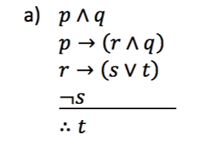

Proof:

1. p ^ q Premise
2. p → (r ^ q) Premise
3. (r ^ q) ^ q Modus Ponens on (1) and (2)
4. r → (s v t) Premise
5. r Conjunctive Simplification on (3)
6. s v t Modus Ponens on (4) and (5)
7. ¬s Premise
8. ∴ t Disjunctive Syllogism on (6) and (7)
9. Q.E.D

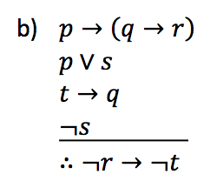

Proof:

1. p v s Premise
2. ¬s Premise
3. p Disjunctive Syllogism on (1) and (2)
4. q → r Modus Ponens on (3)
5. t → q Premise
6. t → r Law of Syllogism on (4) and (5)
7. ∴ ¬r → –t Definition of Contrapositive implication
8. Q.E.D

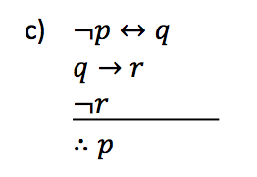

Proof:

1. q → r Premise
2. ¬r Premise
3. ¬q Modus Tollens on (1) and (2)
4. ¬p ⇔ q Premise
5. q ⇔ ¬p Definition of Bi-directional implication on 5
6. ¬¬p Modus Tollens on (3) and (5)
7. ∴ p Double Negation
8. Q.E.D

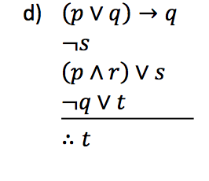

Proof:

1. ¬s Premise
2. (p ^ r) v s Premise
3. p v s Conjunctive Simplification on (2)
4. p Disjunctive Syllogism on (1) and (3)
5. (p v q) → q Premise
6. ¬(p v q) v q Definition of Implication
7. (p ^ q) v q De Morgan’s
8. p v q Conjunctive Simplification on (7)
9. q Disjunctive Syllogism on (4) and (8)
10. ¬q v t Premise
11. t Disjunctive Syllogism on (9) and (10)
12. Q.E.D

2.

a) ∃x (¬q(x) ^ ¬p(x))

b) ∀x(¬r(x) ^ ¬s(x))

c) All menu items that are vegan dishes and do not come with sweet potato fries must come with chilled honeydew melon soup.

d) There is at least one menu item that contains meat and does not come with sweet potato fries.

3.

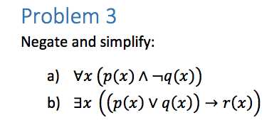

1. Proof:
2. ¬(∀x(p(x) ^ ¬q(x)) Given
3. ∃x (¬(p(x) ^ ¬q(x)) Negation of Quantifiers
4. ∃x (¬p(x) v ¬¬q(x)) De Morgan’s
5. ∃x (¬p(x) v q(x)) Double Negation
6. ∃x (p(x) → q(x)) Definition of Implication
7. Q.E.D
8. Proof:
9. ¬ ∃x ((p(x) v q(x)) → r(x)) Given
10. ∀x ¬((p(x) v q(x)) → r(x)) Negation of Quantifiers
11. ∀x ¬ ((¬p(x) v q(x)) v r(x) Definition of Implication
12. ∀x ((p(x) ^ ¬ q(x)) v r(x) De Morgan’s
13. Q.E.D

4. 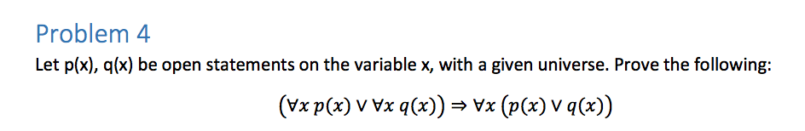

Proof:

1. (∀x p(x) v ∀x q(x)) Premise
2. p(x) v q(x) for any arbitrary x Universal Instantiation on (1)
3. ∀x (p(x) v q(x) Universal Generalization on 2
4. Q.E.D

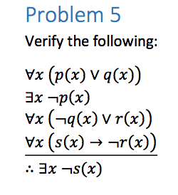

Proof:

1. ∀ (p(x) v q(x)) Premise
2. p(x) v q(x) Universal Specification on (1)
3. ∀x(–q(x) v r(x)) Premise
4. ¬q(x) v r(x) Universal Specification on (3)
5. ∃x ¬p(x) Premise
6. ¬p(x) Existential Instantiation on 5
7. ∀x (s(x) → ¬r(x)) Premise
8. s(x)→ ¬r(x) Universal Specification on (7)
9. q(x) Disjunctive Syllogism on (2)(6)
10. r(x) Disjunctive Syllogism on (4)(9)
11. ¬s(x) v ¬ r(x) Definition of Implication (8)
12. ¬s(x) Disjunctive Syllogism (11)
13. ∃x (¬s(x)) Existential Generalization(12)
14. Q.E.D

6.

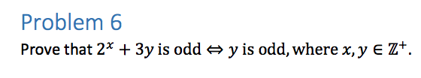

Proof by Contraposition:

1. If y is even, 2x + 3y is even.
2. Y = 2k
3. 2x+3(2k) = 2x+6k = 2x + 2(3k)
4. 2x is even because it is a multiple of 2
5. 3k is an integer
6. Multiplying 3k by two forces the final product to be even.
7. Therefore, 2x + 3y is odd ⇔ y is odd.